Robot Arm

Subject: Biology, Mathematics (Biomedical Engineering)  Related Subjects: | Grade Level(s):  Length of Lesson: | Type: Inquiry / Design / Project  Keywords:

Lesson Overview
Students will design and construct a robot arm to pick up a small object.

Lesson Focus
What is the central question or phenomenon being investigated? What problem are they trying to solve?

Lesson Objective(s) | Students will design and construct a robot arm from card stock, foam board and string.

Lesson Timing

5 minutes | Introduce the Lesson
30 minutes | ...

Materials | - • Foam board  - • Card stock paper  - • String  - • Fasteners  - • Paper clips  - • Scissors  - • Tape
Instructor Prep | - Step 1
Related Resources | - List related lessons/ppts etc available from USC or outside, trusted orgs

Lesson Plan

Introduction
A robotic arm is a robot manipulator, usually programmable, with similar functions to a human
arm. Robotic arms are used to perform a variety of tasks such as in automobile assembly lines
and during Space Shuttle missions.

Procedure
.Xerox “Paper Robot Arm Components Sheet” onto card stock paper
–Carefully cut out the pieces
- –Bend along the long lines and form arm component pieces
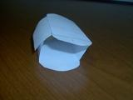
- –Using a thumb tack, poke holes in the component parts
- –Line up the holes from the humerus with holes on the radius/ulna
- –Insert fastener through both sides
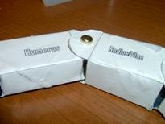
- –Line up the holes from the radius/ulna with holes on the carpal
- –Insert fastener through both sides
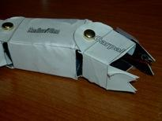
- –Cut a strip of foam board 4” x 2”
- –Cut another strip of foam board 3” x 2”
- –Cut two small pieces of foam board 1” x 2”
- –Create standing post by gluing the two small pieces of foam board on either side of 4” foam board

Side

front

- –Glue the standing post in the center of the 3” foam board

Side

front

- –Tape free side of humerus to the 1” from the top of the standing post
- –Tape a string to the far end of the radius/ulna
- –Tape a string to the far end of the carpal
- –Insert paper clip through top of the standing post
- –Bring free end of radius/ulna string through left side of paper clip
- –Bring free end of carpal string through right side of paper clip (see figure 6)
- –Tape free ends of both strings
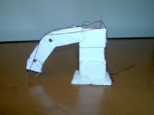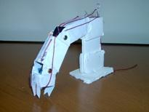

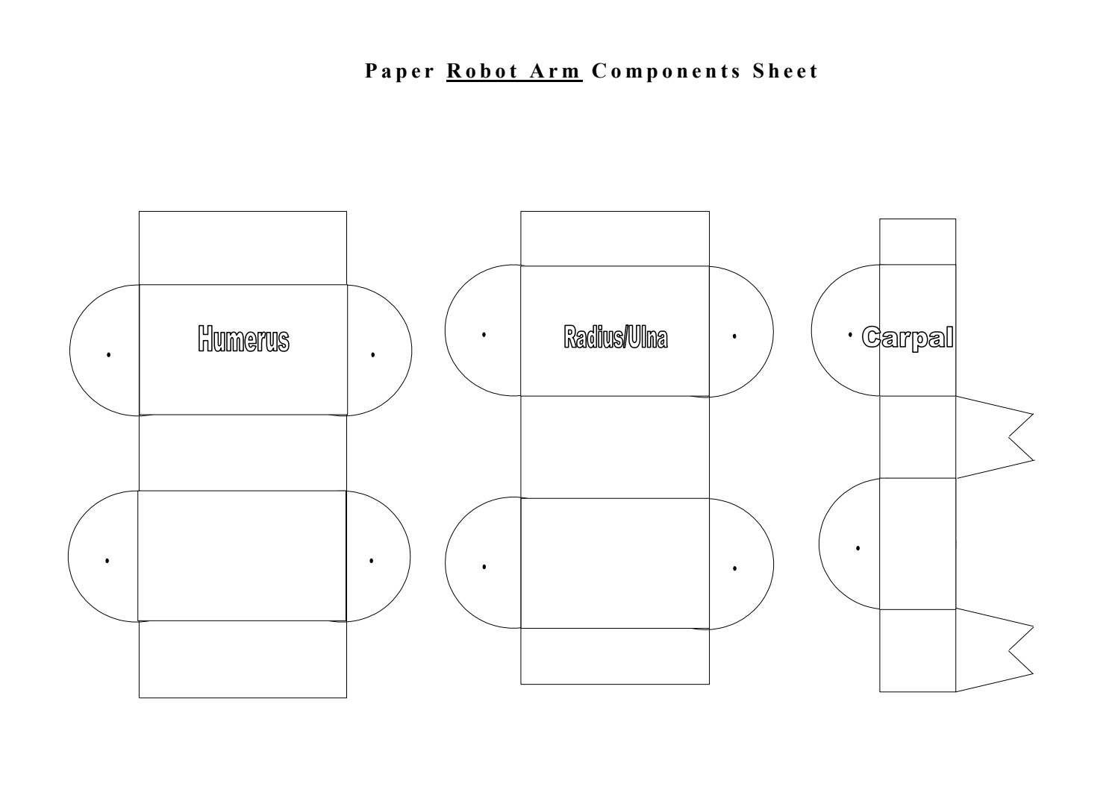

Wrap-up
End the lesson with some final discussions about what students designed/discovered. Connect their activity back to the focus question/problem, real world examples, and STEM careers.

Also include notes about any special cleanup considerations

Lesson Background for Teachers

Suggested Real-World STEM Connections
- List possible related Role Models in STEM (with details and links to more reading). Give suggestions for examples of scientists/engineers who are from underrepresented groups in STEM in related careers.
- List related real-world engineering problems and examples

Lesson Variations and Options
Include descriptions of alternative methods or ways to present things.

Explanation
Describe the background concepts and explanations behind the lesson. This can be more in depth than a teacher/instructor would actually share with students.

Key Concepts and Vocabulary
- Word 1: Grade Appropriate Definition
- Word 2: Grade Appropriate Definition

Safety Notes
- Safety instruction

